Test Case Report

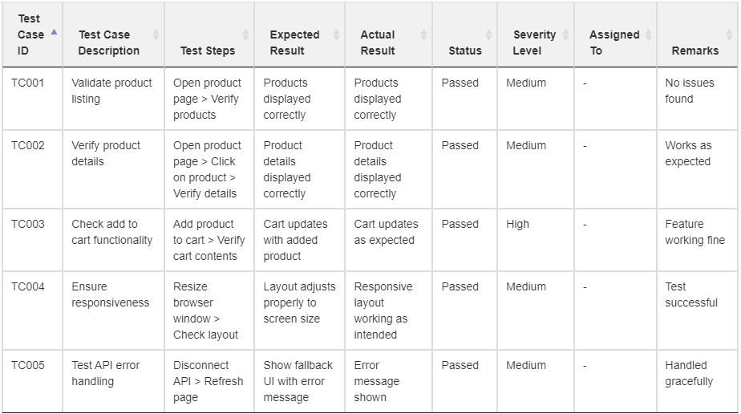

TEST CASE REPORT(CSV Format)

**Test Case ID,Test Case Description,Test Steps,Expected Result,Actual Result,Status,Severity Level,Assigned To,Remarks**

**TC001,Validate product listing,Open product page > Verify products,Products displayed correctly,Products displayed correctly,Passed,Medium,-,No issues found**

**TC002,Verify product details,Open product page > Click on product > Verify details,Product details displayed correctly,Product details displayed correctly,Passed,Medium,-,Works as expected**

**TC003,Check add to cart functionality,Add product to cart > Verify cart contents,Cart updates with added product,Cart updates as expected,Passed,High,-,Feature working fine**

**TC004,Ensure responsiveness,Resize browser window > Check layout,Layout adjusts properly to screen size,Responsive layout working as intended,Passed,Medium,-,Test successful**

**TC005,Test API error handling,Disconnect API > Refresh page,Show fallback UI with error message,Error message shown,Passed,Medium,-,Handled gracefully**